What was Jesus like?
What things do we already know about Jesus? Jot them down below:

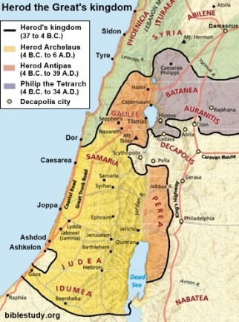
What was 1st century Palestine like and what is the significance of this for Jesus’ ministry?

What is the difference between a gospel and a biography?
………………………………………………………………………………………………………………………………………………………………………………………………………………………………………………………………………………………………………………………………………………………………………………………………………………………………………………………………………………………………………………………………………………………………………………………
Complete the table using the sources attached
Author | Date | What do we learn?
Matthew | c. 80 AD
Luke | c. 85-90 AD
Josephus | c. 93 AD
Pliny the Younger | c. 112 AD
Tacitus | c. 117 AD

